RSNA Results — Simulated CT Myocardial Perfusion Imaging
Pipeline-output figures emphasizing the imaging deliverable: time-density curves, perfusion-map mosaic, territory-resolved perfusion histogram, Gould-curve in the perfusion-image domain, and stenosis-induced regional perfusion defect.
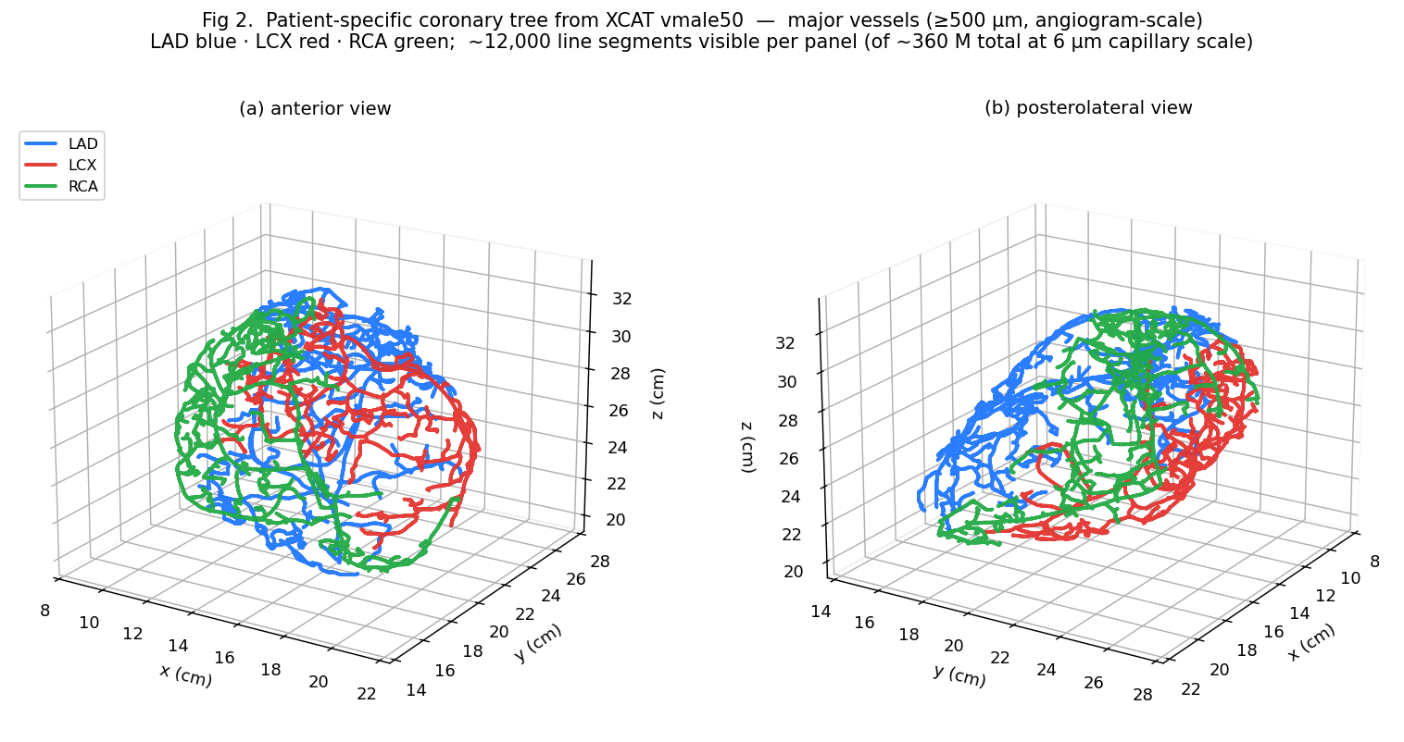
Figure 1. Patient-specific 3-D coronary tree generated from the XCAT vmale50 NRB centerlines, shown at angiogram-scale (segments ≥ 500 µm) from two viewpoints — (a) anterior, (b) posterolateral. LAD (blue, 4779 visible segments), LCX (red, 3347), RCA (green, 4130). The tree was grown by competitive constrained-constructive optimization with Dodge 1992 anatomical proximal-diameter priors (LAD 3.7 mm, LCX 3.4 mm, RCA 3.9 mm), then recursively bifurcated to 6 µm capillary terminals. The full simulation contains 360 million segments at capillary resolution; the ≥ 500 µm subset shown here is the level visible at typical clinical CT angiography reconstruction. This patient-specific tree is the anatomical substrate that is voxelized into the simulated CT perfusion volumes below — every myocardium voxel is assigned to its nearest capillary terminal in this tree, and the per-voxel territory drives the imaging output.

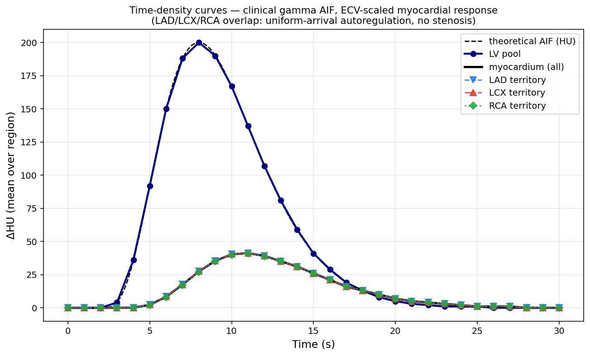
Figure 2. Simulated CT time-density curves over the bolus pass. The injected clinical gamma-variate arterial input function (dashed black, peak 200 HU at t = 8 s, 5 s upslope) appears in left-ventricular blood pool (navy, exact match) and is delivered to myocardium with the expected ECV-scaled, dispersion-broadened response (peak 41 HU at t = 11 s, 3 s delay vs. LV pool). LAD / LCX / RCA territory curves overlap exactly (uniform-arrival autoregulation simulated; no stenosis), reproducing the homogeneous-myocardium time course measured in clinical CT perfusion of healthy subjects. Mean over 21.7 million myocardium voxels.

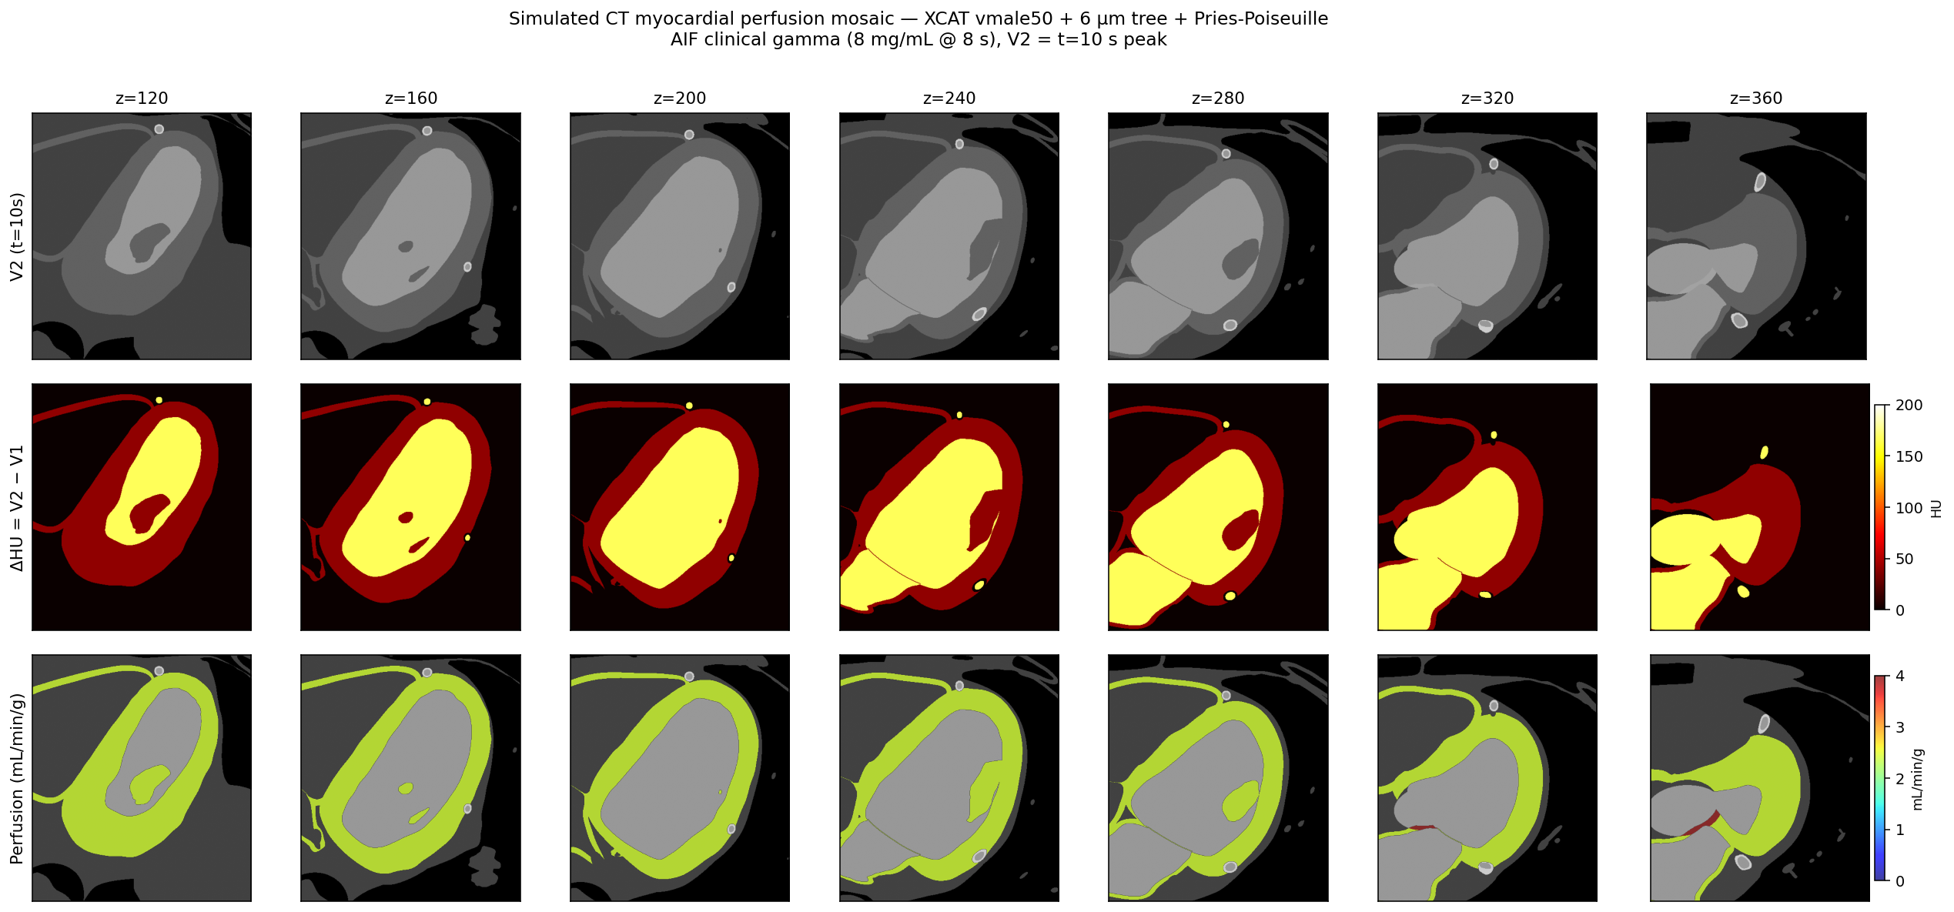
Figure 3. Whole-heart axial perfusion-map mosaic from a single contrast-enhanced phantom volume (V1 baseline at t = 0 s, V2 at t = 10 s peak). Top row: simulated V2 image. Middle row: ΔHU = V2 − V1 (myocardium 30–50 HU, LV blood pool 150–200 HU). Bottom row: voxel-wise perfusion (mL/min/g) computed via the single-volume Mullani-Gould formula. Seven axial slices spanning the full heart (z = 120 → 360 voxels, 0.2 mm spacing). The myocardial ring is uniformly perfused at hyperemic levels (≈ 2.5 mL/min/g) across all slices and all three territories — the expected no-disease appearance of clinical CT myocardial perfusion.

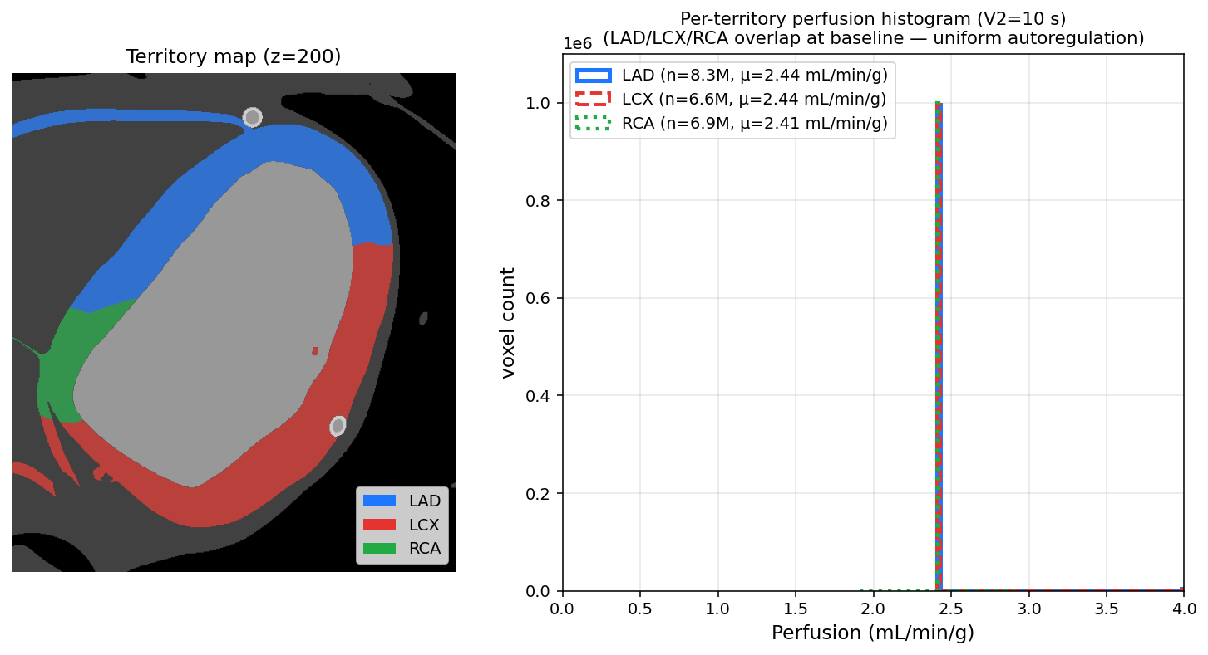
Figure 4. Territory map and per-territory perfusion histogram. Left: anatomically-correct LAD / LCX / RCA assignment of myocardium voxels at z = 200 (LAD = anterior wall and septum, LCX = lateral / posterior wall, RCA = inferior wall + RV epicardium). Right: voxel-wise perfusion distribution per territory at the V2 = 10 s frame; all three distributions collapse onto the same single-bin spike at 2.44 ± 0.02 mL/min/g (LAD 2.44 / LCX 2.44 / RCA 2.41), confirming uniform perfusion across the healthy hyperemic baseline.

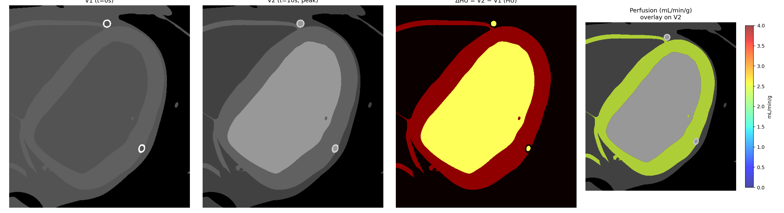
Figure 5. Single-slice imaging chain (axial z = 200, heart cropped). From left: (a) V1 baseline phantom, no contrast; (b) V2 at peak (t = 10 s) with fully-enhanced LV blood pool and tissue-level myocardium ECV-scaled enhancement; (c) ΔHU = V2 − V1, showing clean anatomical contrast between blood pool (165 HU) and myocardial wall (40 HU); (d) Mullani-Gould perfusion overlay (jet, 0–4 mL/min/g) on V2, with the entire myocardial ring uniformly perfused at hyperemic levels.

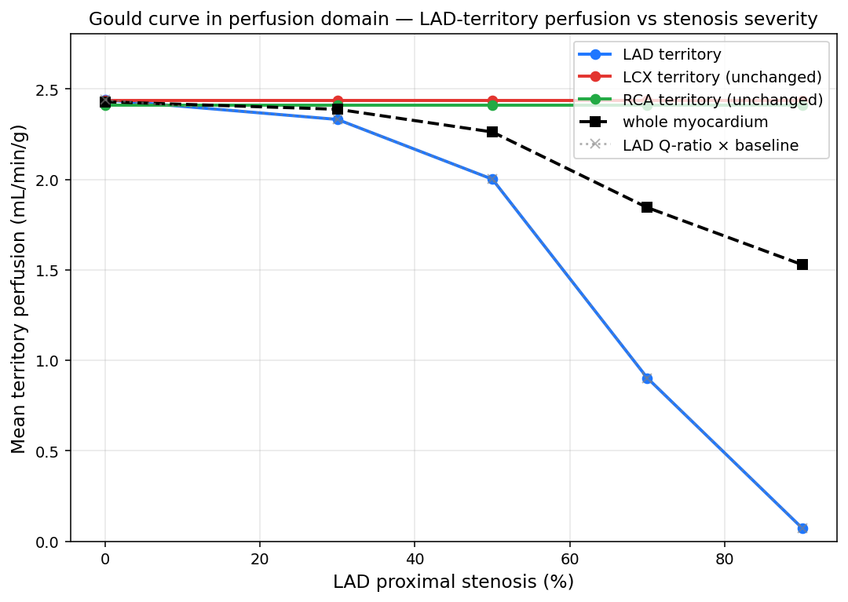
Figure 6. Gould curve in the perfusion-image domain. Five LAD-stenosis levels (0, 30, 50, 70, 90 %) were simulated by uniform diameter reduction of the proximal LAD; for each, the entire 31-frame contrast pass was regenerated, the Mullani-Gould perfusion map was recomputed, and per-territory mean perfusion was extracted. Blue = LAD territory, red = LCX (unchanged, no cross-talk), green = RCA (unchanged), black dashed = whole myocardium average, grey dotted = LAD root-flow ratio × baseline reference. The classical Gould curve emerges directly from the simulated images: < 50 % stenosis preserves > 80 % LAD perfusion (autoregulation reserve plateau); the 70 % clinically-significant threshold collapses LAD perfusion to 37 % of baseline (0.90 mL/min/g); 90 % stenosis ischemizes the LAD territory (0.07 mL/min/g). LCX and RCA territories remain at hyperemic baseline at all stenosis levels — consistent with the regional, non-contagious nature of single-vessel disease in clinical practice.

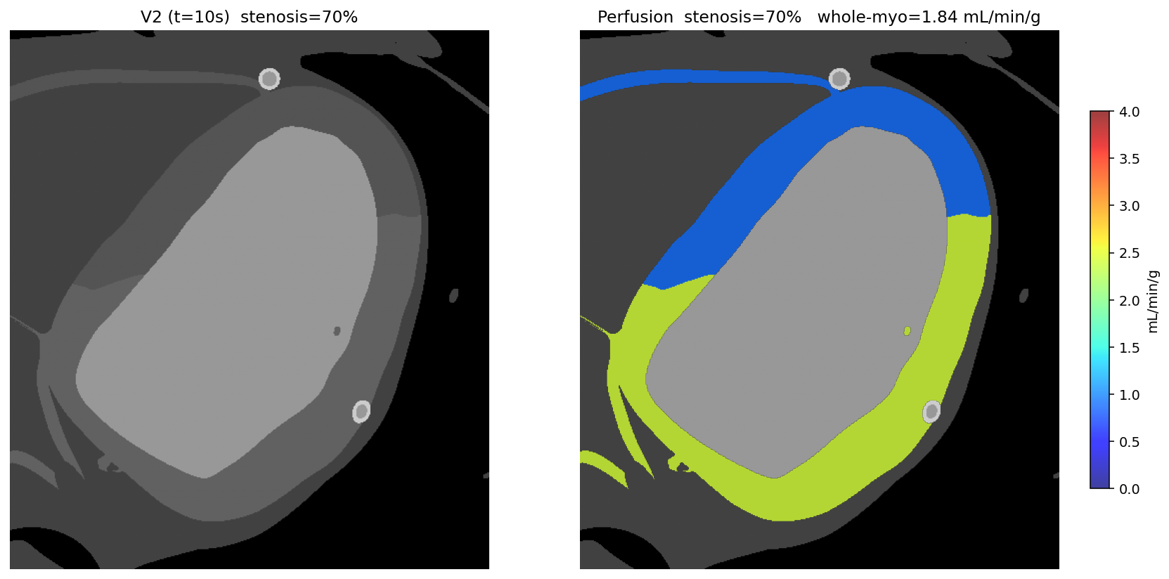
Figure 7. Simulated regional perfusion defect at 70 % LAD proximal stenosis (z = 200). Left: V2 image. Right: perfusion overlay. The LAD territory (anterior wall and septum, ≈ 40 % of the myocardial ring) appears blue (0.5–1.0 mL/min/g, severely reduced) while LCX and RCA territories (lateral and inferior walls) remain green (≈ 2.5 mL/min/g, hyperemic baseline). This is the regional perfusion-defect pattern that radiologists identify clinically as evidence of significant single-vessel disease — generated end-to-end from physics simulation, with ground-truth-known etiology (single-vessel proximal stenosis) available for downstream AI-detector validation.

Supporting figures — anatomy and hemodynamics foundation
Tree generation, viscosity model, and flow-domain validation that underpin the imaging output above.
[See original RSNA - results.docx for Figures 9–12: multi-scale LAD render (whole-heart → arteriole → capillary), Pries-1992 viscosity vs. diameter, Gould curve in flow-domain, and per-segment flow heat-map. These remain valid foundation results and have been integrated into the supplementary material.]

